Pontifícia Universidade Católica de Goiás
Escola de Ciências Médicas, Farmacêuticas e Biomédicas
Curso de Medicina

Pharmacophoric modeling in the investigation of compounds with chemoprotective potential present in the species Mauritia flexuosa

Acadêmicos:
Isabel Cristina Borges de Menezes
João Pedro Carrijo Cunha Camara

Orientador: Prof. Dr. Leonardo Luiz Borges*

Projeto de pesquisa apresentado à PUC-GO – Pontifícia Universidade Católica de Goiás, como parte das exigências para a conclusão do curso de Medicina

Goiânia – Goiás
2022
ABSTRACT: The extract of Mauritia flexuosa, popularly known as “buriti” is rich in bioactive compounds and is characterized as a rich species with antioxidant, antimicrobial, antiplatelet, antitumor, and antilipemic activity. Our methods include using in silico tools to assess biological activities, dynamics, and toxicity prediction. We also performed pharmacophore modeling studies. We found phenolic compounds, flavonoids, carotenoids, fatty acids, and phytosterols. Five flavonoids have predicted chemoprotective activity and affinity for receptors and spatial alignment between the chemical marker present in the M. fleuxosa species and the five ligands with lower IC₅₀ values ​​capable of interacting with their respective targets. In silico pharmacophoric analyzes showed that the most promising structures present in the extract were kaempferol, quercetin, luteolin, apigenin, and caffeic acid, which presented structural alignments according to the analyses. This work opens perspectives to direct future studies in vitro and in vivo with the molecules found during the investigations.
Key-Words: Medicinal plants; Arecaceae; flavonoids; in silico.

1. INTRODUCTION

The extract of Mauritia flexuosa, popularly known as “buriti” is rich in bioactives and is characterized as a rich species composed of antioxidant, antimicrobial, antiplatelet, antitumor and antilipemic activity (FREIRE, J. A. P., et al, 2016; AMORIM, V.R. , et al., 2021). Mauritia flexuosa is an extract of a palm tree that produces fruits which have high levels of provitamin A carotenoids, mainly β-carotene. There is evidence that among the phenolics present in the extract, galic acid,antioxidant and antimicrobial substance with antimutagenic properties, is one of the markers that is found in greater amounts. (BARBOSA, V. F., et al, 2010; BAILÃO, E. F. L. C., et al, 2015).
The antioxidant properties present in the extract are related to a large amount of flavonoids such as tricine-7-O-rutinoside, isoschaftoside, nicotiflorum, rutin, orientin, and isoorientin, in addition to vitamin E, mainly β + γ tocopherol (58.3%). Regarding the antiplatelet and antithrombotic actions, the high amount of mono and polyunsaturated fatty acids confer this activity. Methanolic extracts such as chlorogenic acid and caffeic acid, quercetin and triterpenes from plant roots confer antimicrobial potential. The chlorogenic, protocatechic, and caffeic acids present in the extract are related to lipid-lowering (FREIRE, J. A. P., et al., 2016; AMORIM, V.RANJO, et al., 2021; ABREU-NARANJO, R., et al., 2020).
Some plant extracts showed significant cytotoxic activity in 5 human tumor cell lines (leukemias and colorectal and mammary carcinomas) with results equal to doxorubicin and cisplatin. In addition, a new triterpene was discovered in plant roots, called mauritic acid, which demonstrated significant cytotoxic effects against the OVCAR-8 (ovarian), PC-3M (prostate), and NCIH-358M (pulmonary bronchoalveolar) carcinoma lines ( FREIRE, J. A. P., et al, 2016).
In silico analyzes stand out for using computational tools to predict the biological properties of new molecules. Such approaches are intended to seek the integration of multidisciplinary knowledge about the molecular biology, physiology, and biochemistry of the organism, creating computational models that mimic the organism's functioning in vivo. (NIELSEEN, J., et al, 2014).
In addition to synthetic chemistry as a source of new substances, medicinal plants are an essential source of new molecules with bioactive potential. In silico tools represent an important screening alternative to identify molecules of natural products with greater efficacy potential for future in vitro and in vivo studies and may help establish safety criteria for medicinal plants (JUNIOR, C. V., et al. , 2006).
This study aims to survey the chemical structures present in the species Mauritia flexuosa based on literature data and, later, carry out the screening process for potentially antioxidants molecules and, therefore, have an antimutagenic chemoprotective effect. After selecting the most promising molecules in relation to antioxidant activity, pharmacophoric modeling will be performed with identified target ligands.

2. MATERIALS AND METHODS

The literature survey on the extractor of Mauritia flexuosa was carried out through the servers Science Direct (https://www.sciencedirect.com/), PubMed (https://pubmed.ncbi.nlm.nih.gov/), Scielo (https://scielo.org/pt/) and PubChem (https://pubchem.ncbi.nlm.nih.gov/). The descriptors used were “Mauritia flexuosa” and “chemical compounds”.
After identifying the different realities present in the M. flexuosa species, we screened the bioactivity for chemical markers using PASS Prediction (http://www.way2drug.com/passonline/index.php), Swiss Target Prediction (swisstargetprediction.ch/), Swiss ADME (http://www.swissadme.ch/), Protox II (https://tox-new.charite.de/protox_II/ ), and Super Pred (https://prediction.charite.de/). To predict the pharmacokinetics and target biological activity of the compounds found.
Each screening tool provides a list of possible biological activities for each substance screened according to its structure, using program-specific methodologies. The biological activities with more significant punctuation (antioxidant, antineoplastic, anti-cancer, anti-cancer, and chemoprotective) were selected for specific pharmacophoric mapping.

Pharmacophore modeling

A literature review was performed using the databases in Binding DB to identify compounds with the potential to interact with antioxidants targets. Compounds with the lowest inhibitory concentration (IC₅₀) values were included in a dataset used to obtain pharmacophore models.
Pharmacophore models were generated using the PharmaGist webserver (http://bioinfo3d.cs.tau.ac.il/pharma/about.html), creating 3D pharmacophores from sets of molecules known to bind a common targets receptors that were selected. Pharmagist's algorithm searches for possible pharmacophores and reports the highest-scoring ones. Candidate pharmacophores were identified by multiple flexible alignments of the input ligands, where ligand flexibility is explicitly defined in a deterministic manner for the alignment process (INBAR, Y. et al, 2007; SCHNEIDMAN-DUHOVNY et al., 2008).
Pharmacophore modeling procedures were used to identify the key features of Antioxidants targets described in the literature and search for these features in M. flexuosa compounds. A minimum of three to six features, including hydrogen-bond acceptors, hydrogen bond donors, hydrophobic groups, and aromatic rings, were selected to generate the pharmacophore models. Scoring weights were 3.0 for aromatic rings, 1.0 for charges (anion/cation), 1.5 for hydrogen bond donors or acceptors, and 0.3 for hydrophobic groups. These weights are the default parameters of the webserver.

3. RESULTS

Through the literature survey, we found 60 compounds distributed in leaves, fruits, and extracts of Mauritia flexuosa, belonging to several classes, including fatty acids, phytosterols, flavonoids, carotenoids, and carotenoids.
The compounds in the literature were disclosed to PASS prediction and SwissTargetPredcition, programs to evaluate in silico antineoplastic and antioxidant potential. As a result, 33 compounds demonstrated these activities.
The Swiss Target Prediction and PASS prediction servers were used to predict in silico the biological activities of each molecule. These differences are based on the premise that compounds with similar structures exhibit similar biological activities. Thus, those surveys compare molecules in the study with molecules with known biological functions to predict possible interactions with biological targets.
These surveys were able to assign molecules to targets that were already foreseen by bioinformatics. Besides, its results are widely recognized by several studies that compare already known and valid molecules.
Among the 33 molecules of M. flexuosa, 11 met the four Lipinski criteria and were classified as druglike. Among these 6 were druglikeness without violation: catequin, quercetin, kaempferol, isoschaftoside, luteolin and apigenin and 5 were druglikeness with violation: cafeic acid, ferulic acid, p-coumaric, vinylic acid, and eugenol. Of these, all underwent SwissADME to predict oral bioavailability. It is essential to analyze whether a compound is druglike. In addition to addressing the identification of pharmacological targets, these programs make it possible to assess a drug's potential oral bioavailability. Thus, the evaluation of the pharmacological properties of a compound, in addition to the target affinity, is essential to identify the most promising compounds among a larger set selected for investigation, as was the case in this study.
The parameters calculated for evaluating the druglike behavior of selected compounds from M. flexuosa are presented in Table 1. These parameters assessing the similarity of compounds to known drugs and represent a complex balance of various structural features. Lipinski's rules are widely used to determine molecular properties important for drug pharmacokinetics in vivo. According to Lipinski's rules of five, a candidate molecule is more likely to be orally bioavailable if (a) the molecular weight is less than 500, (b) the calculated octanol/water partition coefficient (log P) is less than 5, (c) the compound has no more than 5 hydrogen bond donors (OH and NH groups), and (d) the compound has no more than 10 hydrogen bond acceptors (mainly N and O).
After classifying the compound for druglike properties, toxicities were predicted. These predictions allow us to define safe dosing parameters for each investigated compound. In addition, toxicity analyses make it possible to establish associations between toxicity and predicted biologically active targets and provide information on the mechanism(s) of action. This initial toxicity screening can serve as a choice criterion to investigate the biological potential of molecules present in this species. We employ the ProTox II web server, a validated toxicity prediction program, to analyze acute toxicity, hepatotoxicity, cytotoxicity, carcinogenicity, mutagenicity, and immunotoxicity.
The median lethal dose (LD₅₀) for each of the eleven compounds (catechin, LD₅₀ = 10,000 mg/kg; quercetin, LD₅₀ = 159 mg/kg; kaempferol, LD₅₀ = 3919 mg/kg; luteolin, LD₅₀ = 3919 mg/kg; apigenin, LD₅₀ = 2500 mg/kg; caffeic acid, LD₅₀ = 2980 mg/kg; Isoschaftoside, LD₅₀ = 536 mg/kg; Ferrulic acid, LD₅₀ = 1772 mg/kg; P-coumaric, LD₅₀ = 2850 mg/kg; vinyl, LD₅₀ = 2000 mg/kg; Eugenol, LD₅₀ = 1930) mg/kg) was investigated. None of the substances showed high toxicity in silico. Toxicity classes ranged from 3 to 6 on a scale in which 1 is the most toxic and 6 the least toxic, with class 5 being the most prevalent, therefore, they have wide therapeutic windows, justifying their use.
The SuperPred server is online software that seeks chemical similarity between the 2D structures of target molecules and known ligands of human biological targets. This software allows the evaluation of the structural requirements of a compound for interaction with a biologically active target. This is beneficial to drug discovery as it allows bioinformatics-based analyses of molecular characteristics necessary for interaction with a biological target. In addition, it contributes to the development of alternative research methods that rely on computer simulations, thus minimizing the use of animals in scientific research, and optimizing time and costs.
These eleven compounds were evaluated for potential interactions concerning antimutagenic, antioxidant, and antitumor activities with human receptors.
The main drugs used in the treatment of chronic degenerative diseases and cancers have several side effects, which can contribute to non-adherence to treatment. In this way, the investigation of cerrado fruits, such as Mauritia flexuosa, will be able to raise new compounds with fewer side effects and with efficiency, which should be tested in future in vitro and in vivo assays.

Table 1 – Characteristics of promising druglike structures present in Mauritia flexuosa, determined by SwissADME.
Compound | Abs GI | Citocroms | LD 50 | Violations | Log P | structure
Quercetin | High | Does not inhibit  CYP | 159mg/kg | 0 | -7,21 cm/s | 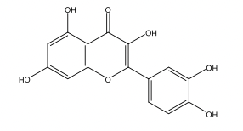
Kaempferol | High | Inhibitor CYP1A2, CYP2D6, CYP3A4 | 10000mg/kg | 0 | -6.70 cm/s | 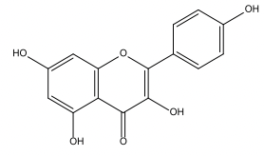
Luteolin | High | Inhibitor  CYP1A2, CYP2D6, CYP3A4 | 3919mg/kg | 0 | -6,25 cm/s | 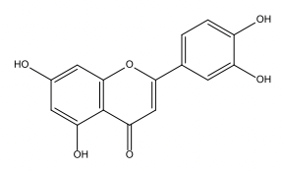
Catechin | High | Does not inhibit  CYP | 3919mg/kg | 0 | -7,82 cm/s | 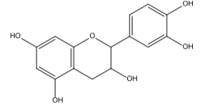
Cafeic Acid | High | Does not inhibit  CYP | 2980mg/kg | 1 | -6,58 cm/s

Pharmacophoric Model

Caffeic Acid
According to Figure 1, it is possible to observe the spatial alignment between the chemical marker present in the M. fleuxosa species and the 5 ligands with lower IC₅₀ values ​​capable of interacting with the Carbonic Anhydrase II target. It is possible to observe that caffeic acid shares 4 spatial characteristics with these ligands: 1 aromatic ring and 3 hydrogen bond acceptors.

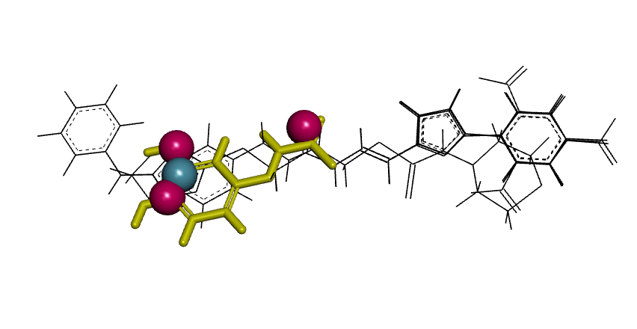
Figure 1. Caffeic acid to the pharmacophore of carbonic anhydrase II. Pharmacophore characteristics are color-coded for hydrogen bond acceptors (red) and aromatic rings (blue).

Apigenin
According to Figure 2, it is possible to observe the spatial alignment between the chemical marker present in the M. fleuxosa species and the 5 ligands with lower IC₅₀ values ​​capable of interacting with aldose reductase. It is possible to observe that apigenin shares 4 spatial characteristics with these ligands, which are: 1 aromatic ring and 3 hydrogen bond acceptors.
Figure 2. Apigenin to the pharmacophore of Aldose reductase. Pharmacophore characteristics are color-coded for hydrogen bond acceptors (red), and aromatic rings (blue).

Kampferol
According to Figure 3, it is possible to observe the spatial alignment between the chemical marker present in the M. fleuxosa species and the 5 ligands with lower IC₅₀ values ​​capable of interacting with the aldose reductase target. It is possible to observe that kaempferol shares 4 spatial characteristics with these ligands: 1 aromatic ring and 3 hydrogen bond acceptors.
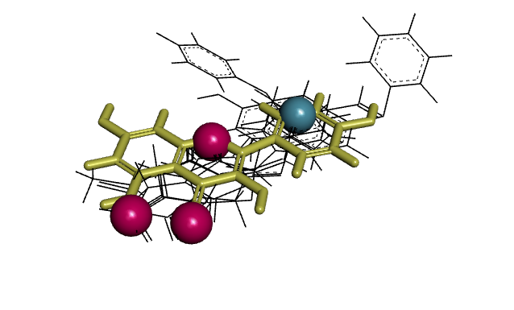
Figure 3. Kampferol to the aldose reductase pharmacophore. Pharmacophore characteristics are color-coded for hydrogen bond acceptors (red), and aromatic rings (blue).

Quercetin
According to Figure 4, it is possible to observe the spatial alignment between the chemical marker present in the M. fleuxosa species and the 5 ligands with lower IC₅₀ values ​​capable of interacting with the P-glycoprotein 1 target. It is possible to observe that kaempferol shares 3 spatial characteristics with these ligands, which are: 3 aromatic rings.
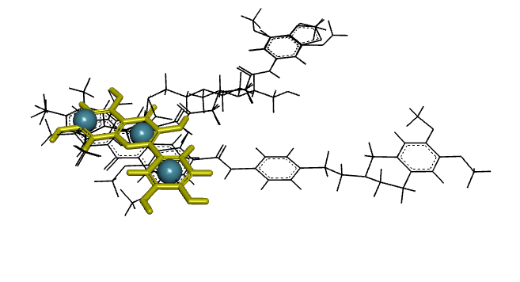
Figure 4. Quercetin with P-glycoprotein 1 pharmacophore. Pharmacophore characteristics are color-coded for aromatic rings (blue).

Luteolin
According to Figure 5, it is possible to observe the spatial alignment between the chemical marker present in the M. fleuxosa species and the 5 ligands with lower IC₅₀ values ​​capable of interacting with the target luteolin 1. It is possible to observe that luteolin shares 3 characteristics with these ligands, which are: 1 aromatic ring and 3 hydrogen bond acceptors.

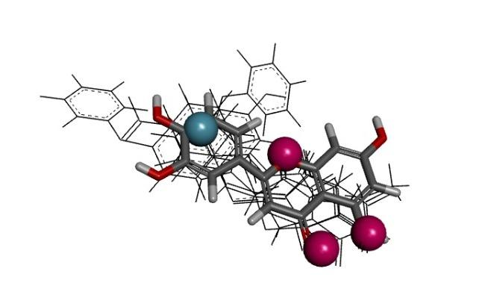
Figure 5.Luteolin to the aldose reductase pharmacophore. Pharmacophore characteristics are color-coded for hydrogen bond acceptors (red), and aromatic rings (blue).

4. DISCUSSION
Flavonoids are a set of plant pigments that are widely distributed in plants (SIMOES et al., 2010). It has in its chemical structure diphenylpropane, which consists of two aromatic rings joined by an oxygenated heterocyclic ring. Substitutions of aromatic rings originate from different compounds within each class of flavonoids (HERTOG et al., 1993; ANGELO & JORGE, 2007). Several compounds with antioxidant activity have been isolated from medicinal plants and functional foods, and phenolic compounds are certainly the most representative substances (FONSECA, 2009). They are bioactive compounds due to their effects: anti-inflammatory, antineoplastic, antibacterial, antimutagenic, vasodilator and antioxidant. Its antioxidant effect is mainly due to eliminating excess reactive oxygen species, preventing lipid peroxidation (CHEN et al., 2018; EGHBALIFERIZ & IRANSHAHI, 2016). The great advantage of these compounds as potential drugs is their low toxicity compared to other substances (PASTENE et al, 2009).
Quercetin is an effective flavonoid in treating and preventing diseases as it influences glutathione, enzymes, signal transduction pathways, and the production of reactive oxygen species. This substance increases the body's antioxidant capacity by regulating GSH levels. In reasonable doses, quercetin is non-toxic and has a number of inhibitory effects on various forms of tumor formation. The anti-cancer properties against lung, prostate, liver, breast, colon, and cervical cancer are mediated by mechanisms in cell signaling pathways and enzymatic activities that inhibit carcinogens, promoting apoptosis, inhibiting metastasis, and their ability to regulate cell cycle and tumor angiogenesis (XU et al., 2019; MINTANG, S., et al, 2020).
This substance regulates the internal and external pathways of protein signaling mediated by reactive oxygen species (PKC), which inhibits cell proliferation and survival and induces apoptosis in cancer cells. In addition, it regulates p53, which is the most common inactivated tumor suppressor. It also increases BAX expression and normalizes the expression of some increased receptors in cancers, such as insulin-like growth factor 1 receptor (IGFIR), AKT, and androgen receptor (AR) (XU et al., 2019; ERSOZ et al., 2019; ERSOZ et al. al., 2020).
Approximately 30-40% of cancers are due to chronic inflammation. Apigenin has been shown to have anti-inflammatory, antioxidant, and anti-cancer properties by regulating the main signaling pathways associated with inflammation: NF-κB, STAT3/6, Akt/mTOR. This substance inhibits cancer cell proliferation as it increases autophagy, apoptosis, and immune response (SHARMA et al., 2019).
The study showed that apigenin acts on breast cancer cells by modulating bcl-2 (B2 cell lymphoma), BAX (BCL2, Apoptosis Regulator), STAT-3 (Signal Transducer and Transcription Activator 3), and AKT (ALDAWSARI) protein expression et al., 2021).
Among the flavonoids, kaempferol stands out, mainly due to its antioxidant and cytoprotective effect (JAMALAN et al., 2016). The possible association between consumption of kaempferol-containing foods and a reduced risk of developing various disorders, including cancer and cardiovascular disease, is related to its antioxidant capacity. Therefore, in vitro and in vivo studies have demonstrated the antioxidant effect of kaempferol against various types of cancer, including ovarian (ZHAO et al., 2017), lung (KUO et al., 2015), pancreas (ZHANG et al., 2008) , stomach (SONG et al., 2015), prostate (HALIMAH et al., 2015) and others.

These studies demonstrate that the ability of kaempferol to act against oxidative stress is linked to its ability to eliminate reactive oxygen species, which is attributed to its ability to increase the activity of antioxidant enzymes, such as superoxide dismutase (SOD), catalase, and heme-oxygenase (ZHANG et al., 2017; LIN et al., 2003; HONG et al., 2009). The antioxidant mechanism of kaempferol is intrinsically related to the hydroxyl groups capable of donating hydrogen to reactive oxygen species, resulting from the activation of nicotinamide adenine dinucleotide phosphate oxidase (NADPH oxidase).
Caffeic acid (3,4-dihydroxy cinnamic acid) is one of the most important phenolic compounds, with several pharmacological properties. It is naturally found in many products such as fruits, vegetables, wine, olive oil, and coffee, therefore often present in the human diet. Caffeic acid has been reported for its wide variety of biological activities, including antioxidant, antithrombosis, antihypertensive, antifibrotic, 21 antiviral properties, acting as an important radical scavenging agent, and also as a metal ion chelator (PRASAD et al, 2010).
This phenolic antioxidant compound, capable of neutralizing free radicals that can cause oxidative damage to cell membranes and DNA, is one of the most widely distributed hydroxycinnamates and can be found in various forms as esters and amides (FU et al., 2010).
Like most flavonoids, Luteolin is considered an excellent antioxidant that is able to inhibit reactive oxygen species resulting from inducing damage to lipids, DNA, and proteins. Multiple mechanisms may explain the antioxidant effects of luteolin. These mechanisms include the "scavenger" function of these reactive oxygen species through their oxidation, the inhibition of the generation of ROS-oxidase, enhancing the endogenous antioxidants, and the direct inhibition of enzymes that catalyze the oxidation of cellular components. (GONÇALVES et al., 2004; JOHNSON et al., 2008)

5. CONCLUSION
The incidence of chronic degenerative diseases such as cancers has been increasing in recent years. Thus, it is essential to search for new drugs, preferably with fewer side effects, whose medicinal plants represent a potential source. The pharmacophoric analyzes of this study showed that the most promising structures present in the extract according to the Mauritia flexuosa in silico tools were kaempferol, quercetin, luteolin, apigenin, and caffeic acid, which presented structural alignments according to the analyses. It is necessary to investigate new drug candidates and the molecular mechanisms involved to improve knowledge in this field of study. This work, finally, opens perspectives to direct future studies in vitro and in vivo with the molecules found during the analyses to reach the possibility of finding promising antioxidant and antimutagenic drugs.

6. REFERENCES
- FREIRE, J. A. P., BARROS, K. B. N. T., LIMA, L. K. F., et al. Phytochemistry Profile, Nutritional Properties and Pharmacological Activities of Mauritia flexuosa. Journal of Food Science, v.81 , n.11, nov. 2016.

- BAILAO, E. F. L. C., DEVILLA, I. A., CONCEICAO, E. C., BORGES, L. L. Bioactive Compounds Found in Brazilian Cerrado Fruits. International Journal of Molecular Sciences, v. 16, p. 23760-23783, sep. 2015.

- SANTOS, J.; ROSA, P. C.; Estudo da Composição Química, Citotoxicidade e Viabilidade Celular do Óleo Essencial de Copaíba, 10.19146/pibic-2017-78180.

- MARIA, M. F. et al. MTT colorimetric assay for testing macrophage cytotoxic activity in vitro. Journal of Immunological Methods, v. 131, n. 2, p. 165-172, aug.1990.

- RISS T.L.; MORAVEC R.A.; NILES A.L. et al. Cell Viability Assays. Assay Guidance Manual [Internet], may 2013.

- ALVES, C. C. F. et al . Antiproliferative activity of essential oils from three plants of the Brazilian Cerrado: Campomanesia adamantium (Myrtaceae), Protium ovatum (Burseraceae) and Cardiopetalum calophyllum (Annonaceae). Braz. J. Biol., Apr, 2019.

- MESQUITA M. L., et al. Cytotoxic activity of Brazilian Cerrado plants used in traditional medicine against cancer cell lines. Journal of Ethnopharmacology, vol. 123, n. 3, p. 439-445, jun. 2009.

- BAHUGUNA, A.; KHAN, I.; BAJPAI, V.; KANG, S. MTT assay to evaluate the cytotoxic potential of a drug. Bangladesh Journal of Pharmacology, v. 12, n. 2, p. Available Online: Apr 8, 2017, 8 abr. 2017.

- FERRARI, M., FORNASIERO M.C., ISETTA A. M., MTT colorimetric assay for testing macrophage cytotoxic activity in vitro. Journal of Immunological Methods, v. 131, n. 2, p. 165-172, Aug.1990.

- PERES, .L. A. B., DELFINO, V. D. A., MOCELIN, A. J., TUTIDA, L. A., FAVERO, M.E., MATSUO, T. Padronização do teste do MTT em modelo de preservação a frio como instrumento de avaliação da viabilidade celular renal. Braz. J. Nephrol, v.30, p. 48-53, jan. 2008.

- BARBOSA, V. F. Caracterização do perfil da ação do ácido gálico e seus derivados sobre processos oxidativos in vitro e ex vivo. Dissertações - Biociências e Biotecnologia Aplicadas à Farmácia - FCFAR, aug. 2010.

- ESTEVAM, ELIS NGELA B.B. et al . In vitro antiparasitic activity and chemical composition of the essential oil from Protium ovatum leaves (Burceraceae). An. Acad. Bras. Ciênc., Rio de Janeiro, v. 89, n. 4, p. 3005-3013, Dec. 2017.

- AMORIM, V. R., RODRIGUES, D. C. D. N., SILVA J. D. N., et al. Anti-inflammatory mechanisms of fruits and by-products from Mauritia flexuosa, an exotic plant with functional benefits. J Toxicol Environ Health A. v 28, n. 1, p. 1-17, Feb. 2021.

- ABREU-NARANJO, R., PAREDES-MORETA, J. G., GRANDA-ALBUJA, G., et al. Bioactive compounds, phenolic profile, antioxidant capacity and effectiveness against lipid peroxidation of cell membranes of Mauritia flexuosa L. Fruit extracts from three biomes in the Ecuadorian Amazon. Heliyon. v. 16, n. 6, e05211, Oct. 2020.

- FAUSTINO PEREIRA, Y. et al. Modulation of the Antibiotic Activity by the Mauritia flexuosa (Buriti) Fixed Oil against Methicillin-Resistant Staphylococcus Aureus (MRSA) and Other Multidrug-Resistant (MDR) Bacterial Strains. Pathogens, v. 7, n. 4, p. 98, 10 dez. 2018.

- INBAR, Y. et al. Deterministic Pharmacophore Detection via Multiple Flexible Alignment of Druglike Molecules. Lecture Notes in Computer Science, 3692, 423- 434, 2007.

- SCHNEIDMAN-DUHOVNY, D. et al. PharmaGist: a webserver for ligand-based pharmacophore detection. Nucleic Acids Research, v. 36, n. Web Server, p. W223–W228, 19 maio 2008.

- XU, D. et al. Antioxidant Activities of Quercetin and Its Complexes for Medicinal Application. Molecules, v. 24, n. 6, p. 1123, 21 mar. 2019.

- MINTANG, S., et al. Pharmacological basis and new insights of quercetin action in respect to its anti-cancer effects. Biomedicine & Pharmacotherapy, v. 121, p. 109604, 1 jan. 2020.

- ERSOZ, M. et al. Quercetin-loaded nanoparticles enhance cytotoxicity and antioxidant activity on C6 glioma cells. Pharmaceutical Development and Technology, v. 25, n. 6, p. 757–766, 20 mar. 2020.

- ALDAWSARI, M. F. et al. Development and Characterization of Calcium-Alginate Beads of Apigenin: In Vitro Antitumor, Antibacterial, and Antioxidant Activities. Marine Drugs, v. 19, n. 8, p. 467, 1 ago. 2021.

- CICEK, M. et al. Investigation of oxidant/antioxidant and anti‐inflammatory effects of apigenin on apoptosis in sepsis‐induced rat lung. Journal of Biochemical and Molecular Toxicology, v. 35, n. 5, 18 fev. 2021.

- SHARMA, A. et al. Probing into Therapeutic Anti-cancer Potential of Apigenin: Recent Trends and Future Directions. Recent Patents on Inflammation & Allergy Drug Discovery, v. 13, n. 2, p. 124–133, 2019.

- GONÇAVES, J. A.; PEIXOTO, C. P.; LEDO, C. A. S. Componentes de produção de amendoim em diferentes arranjos espaciais no Recôncavo Baiano. Revista Brasileira de Oleaginosas e Fibrosas, Campina Grande, v.8, n. 2/3, p. 801-812, maio-dez. 2004.

- JOHNSON; KELLEY, KW; JOHNSON, RW ;. "Luteolin reduces IL-6 production in microglia by inhibiting JNK phosphorylation and activation of AP-1". Proc. Natl. Acad. Sci. U.S.A. 105 (21): 7534–9; 2008.

- CHEN, J. et al. Meta-analysis: Overweight, obesity, and Parkinson’s disease. International Journal of Endocrinology. 2014.

- EGHBALIFERIZ, S.; IRANSHAHI, M. Prooxidant Activity of Polyphenols, Flavonoids, Anthocyanins and Carotenoids: Updated Review of Mechanisms and Catalyzing Metals. Phytotherapy Research. (March), 1379–1391. 2016.

- SIMÕES, C. M. O; SCHENKEL, E. P; GOSMANN, G; MELLO, J. C. P; MENTZ, L. A; PETROVICK, P. R. Farmacognosia: Da planta ao medicamento. 6. ed. Porto Alegre/Florianópolis: Universidade Federal do Rio Grande do Sul, 2010, 1102 p.

- ANGELO, P. M; JORGE, N. Compostos fenólicos em alimentos – Uma breve revisão. Revista Instituto Adolfo Lutz, São Paulo, v. 66, n. 1, p. 1-9, 2007.
- HERTOG, M. G. L; FESKENS, E. J. M; HOLLMAN, P. C. H; KATAN, M. B; KROMHOUT, D. Dietary antioxidant flavonoids and risk of coronary heart disease: the Zutphen elderly study. The Lancet Journal, United Kingdom v. 342, n. 8878, p. 1007- 1011, 1993.
- FONSECA, A.M. Constituents and antioxidant activity of two varieties of coconut water (Cocos nucifera L.). Rev Bras Farmacogn v.19, p.193-198, 2009.
- PASTENE, E., SPEISKY, H., TRONCOSO, M., ALARCON, J., FIGUEROA, G. In Vitro Inhibitory Effect of Apple Peel Extract on the Growth of Helicobacter pylori and Respiratory Burst Induced on Human Neutrophils. J Agric Food Chem, v.57, p.7743–7749, 2009.

- PRASAD, N.R.; KARTHIKEYAN, A.; KARTHIKEYAN, S.; REDDY, B.V. Inhibitory effect of caffeic acid on cancer cell proliferation by oxidative mechanism in human HT-1080 fibrosarcoma cell line. Mol Cell Biochem, 2010.

- FU, J.; CHENG, K.; ZHANG, Z.; FANG, R.; ZHU, H. Synthesis, structure and structure– activity relationship analysis of caffeic acid amides as potential antimicrobials. Eur J Med Chem, v. 45, p. 2638-2643, 2010.
- ZHANG, R.; AI, X.; DUAN, Y.; XUE, M.; HE, W.; WANG, C.; XU, T.; XU, M.; LIU, B.; LI, C.; WANG, Z.; ZHANG, R.; WANG, G.; TIAN, S.; LIU, H. Kaempferol ameliorates H9N2 swine influenza virus-induced acute lung injury by inactivation of TLR4/MyD88-mediated NF-kB and MAPK signaling pathways. Biomed Pharmacother., v. 89, p. 660-672, 2017.
- HONG, J-T.; YEN, J-H.; WANG, L.; LO, Y-H.; CHEN, Z-T.; WU, M-J. Regulation of heme oxygenase-1 expression and MAPK pathways in response to kaempferol and rhamnocitrin in PC12 cells. Toxicol Appl Pharmacol. v.237, p. 59-68, 2009.
- SONG, H.; BAO, J.; WEI, Y.; CHEN, Y.; MAO, X, LI; J., YANG, Z.; XUE, Y. Kaempferol inhibits gastric cancer tumor growth: An in vitro and in vivo study. Oncol Rep, v. 33, 2, p. 868-874, 2015.
- JAMALAN, M.; GHAFFARI, M.A.; HOSEINZADEH, P.; HASHEMITABAR, M.; ZEINALI, M. Human sperm quality and metal toxicants: protective effects of some flavonoids on male reproductive funcHon. Int J Fertil Steril., v. 10, n. 2, D.215-222, 2016.
- ZHANG, Y.; Chen, A. Y.; Li, M.; Chen, C.; Yao, Q. Ginkgo biloba extract kaempferol inhibits cell proliferation and induces apoptosis in pancreatic cancer cells. J Surg Res., v. 148, n. 1, p. 17-23, 2008.
- ZHAO, Y.; ZHANG, Y.; LI, J.; ZHENG, N.; XU, X.; YANG, J.; XIA, G.; ZHANG, M. MAPK3/1 participates in the activation of primordial follicles through mTORC1-KITL signaling. J Cell Physiol., v. 233, p.226-237, 2017.

- HALIMAH, E.; DIANTINI, A.; DESTIANI, D. P.: PRADIPTA, I. S.: SASTRAMIHARDJA, H. S.; LESTARI, K.; SUBARNAS, A.; ABDULAH, R.; KOYAMA, H. Induction of caspase cascade pathway by kaempferol-3-0- rhamnoside in LNCaP prostate cancer cell lines. Biomed Rep., v. 3, n. 1, P.115-117.2015.

- KUO, W. T.; TSAI, Y. C.. WU, H. C.; HO, Y. J.; CHEN, Y. S.; YAO, C. H.; YAO, C. H. Radiosensitization of non-small cell lung cancer by kaempferol. Oncol Rep., v. 34, n. 5, 2351-2356, 2015.

